Frederick Costello
Assignment M7
05/02/2026
CSD-325-T301

City functions with city and country (item a).
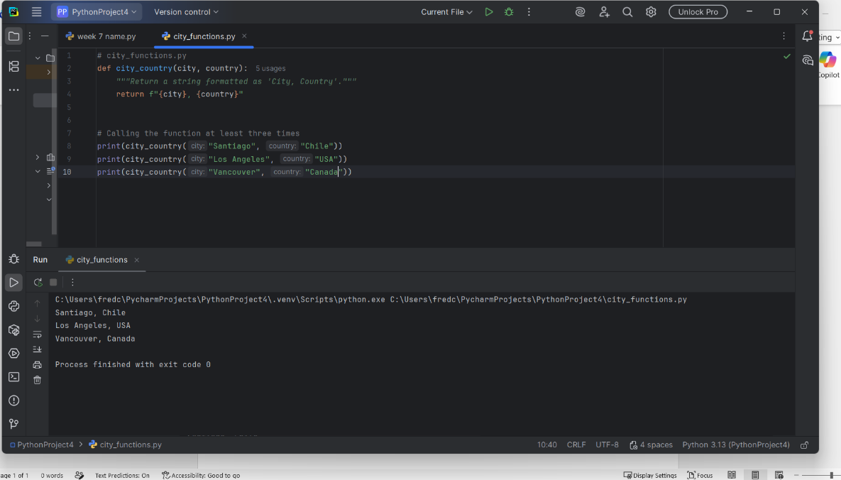

test code “test_cities.py” (item b)
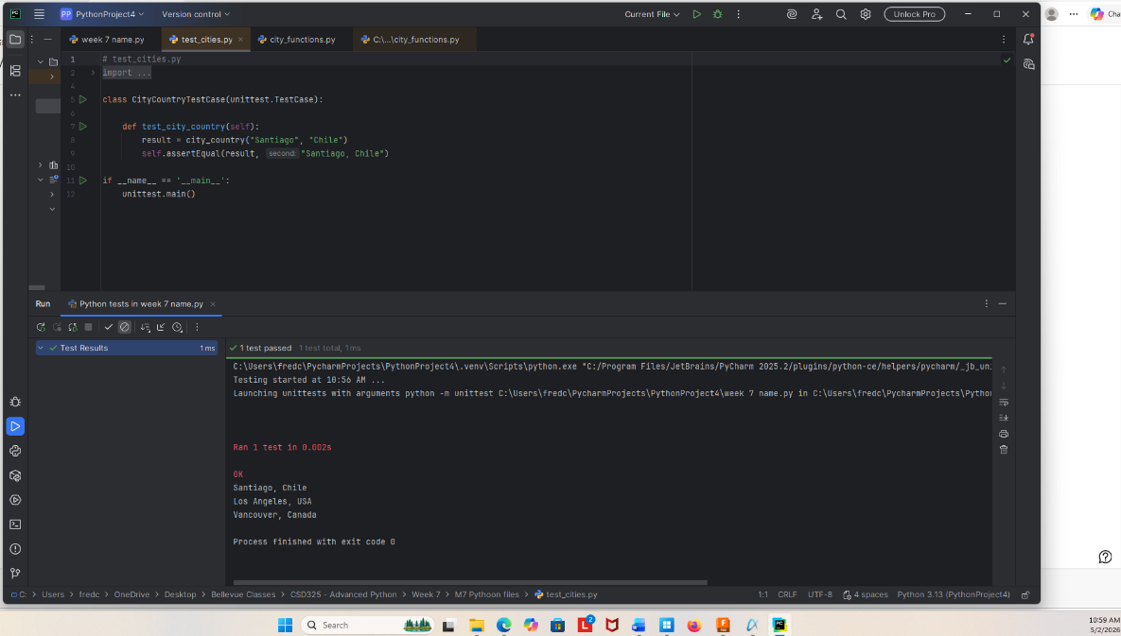

city function modified to add population (item c)
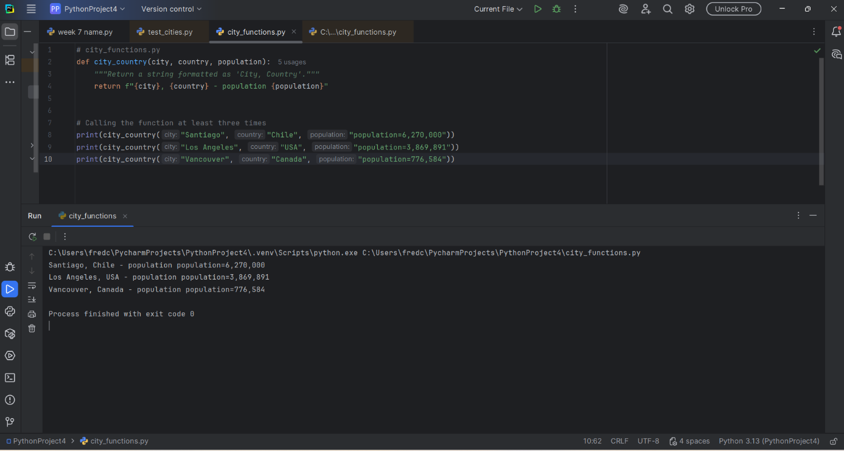

Test run again with population added but not optional. Test fail (Item d)
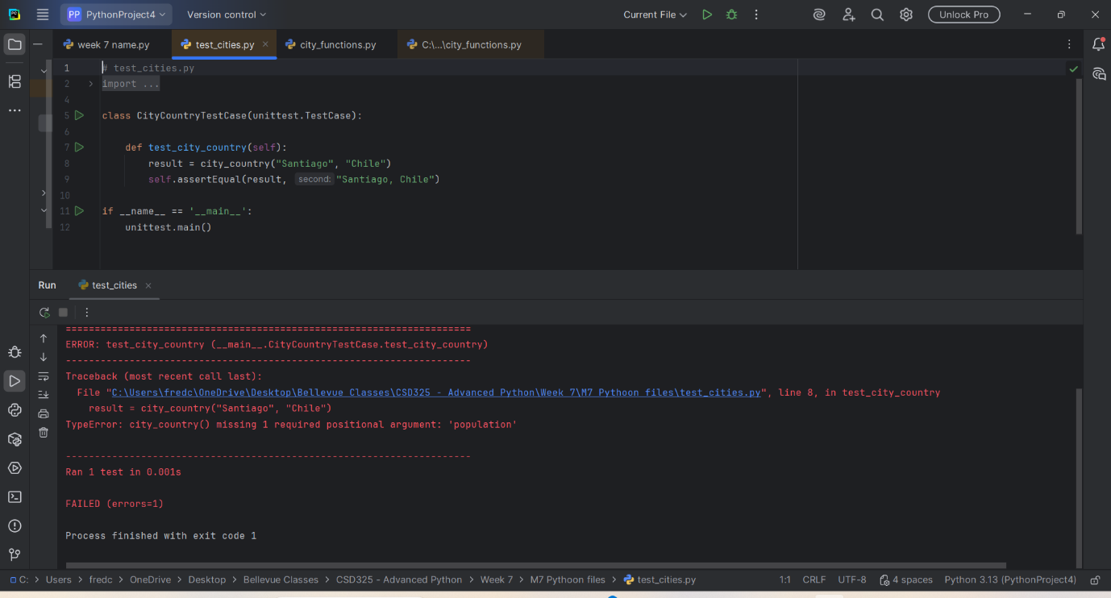

City function has population as optional. (item e)
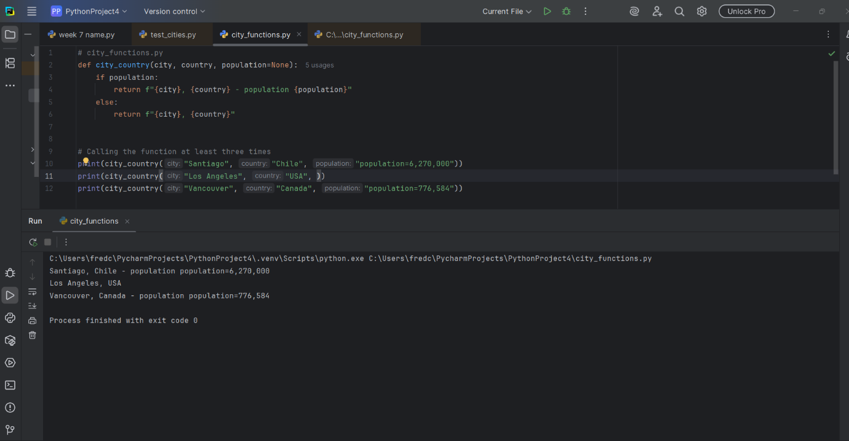

Test run with population as optional. Test successful (item f)
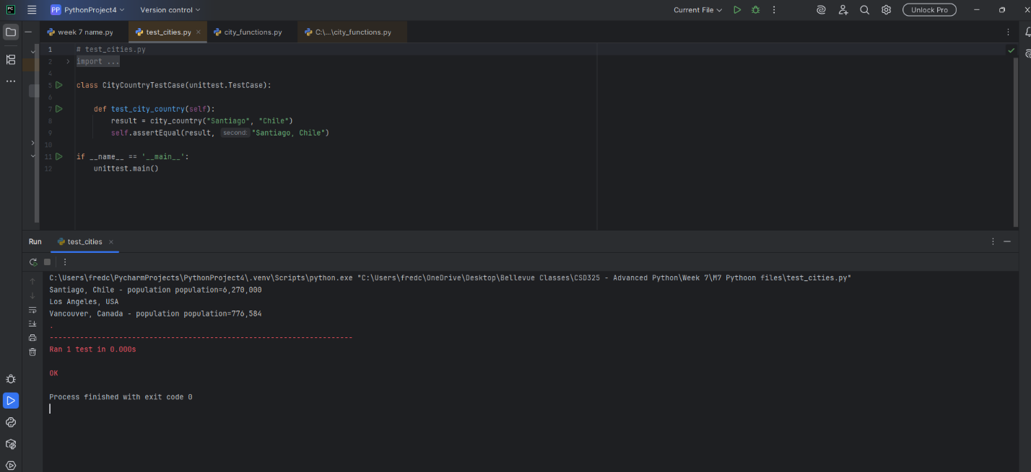

City function modified to add 4th parameter “Language” (item g)
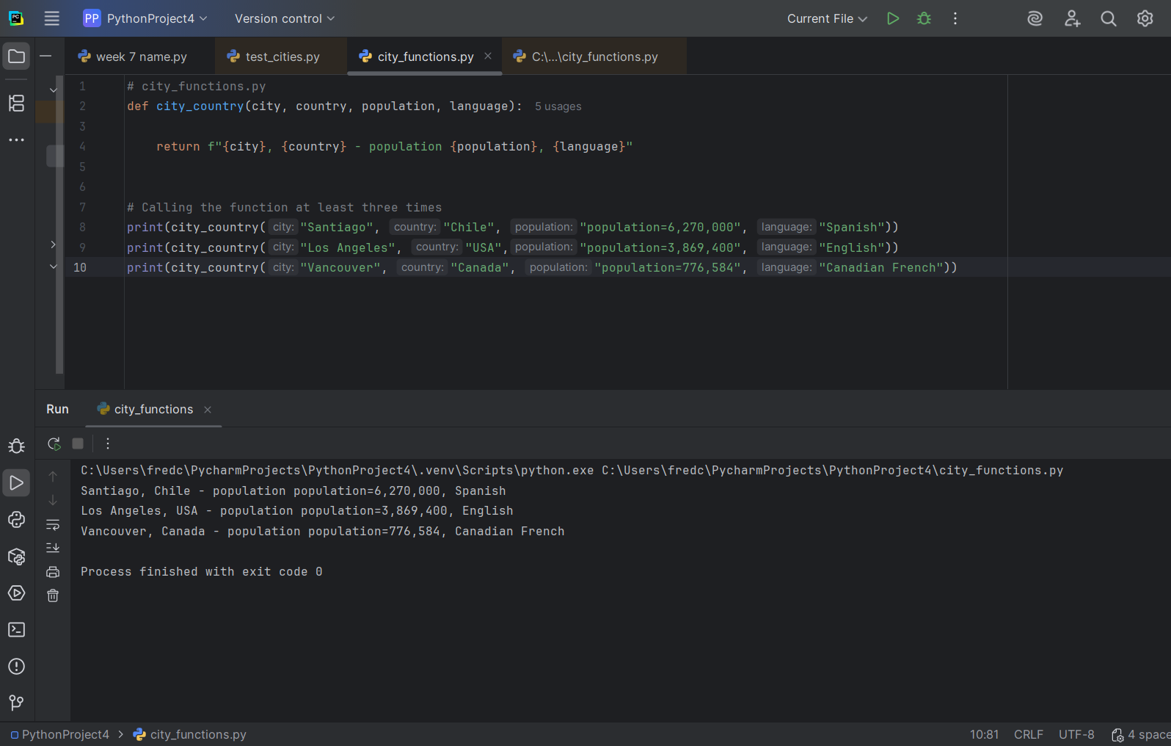

Test run and failed with language added (item h)
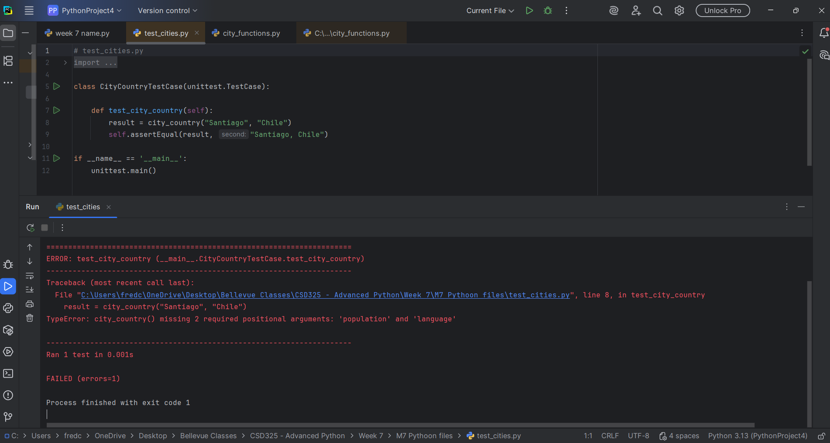
City function altered so language is optional (item i)
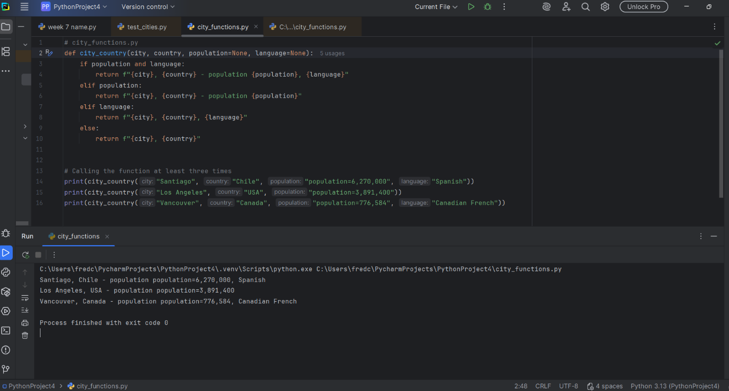

Test is successful after language is made optional (item j)
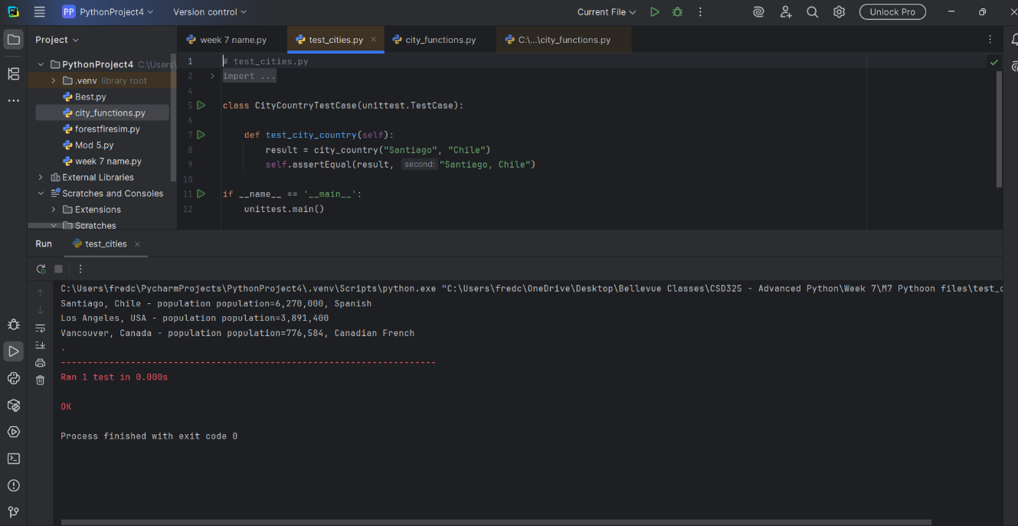

City functions calls function 3 times “1: City, Country”, “2: City, Country, Population”, “3: City, Country, Population, Language”. (item k)
